// check for two spaces between sentences
// check for spelling, grammar errors
// check for future, present tense usage
// check for sentences that will be difficult for ROMAN to understand
// argh,

4. High Level Design

4.1 Conceptual View

Conceptual View of XGene 360 (Component Diagram):

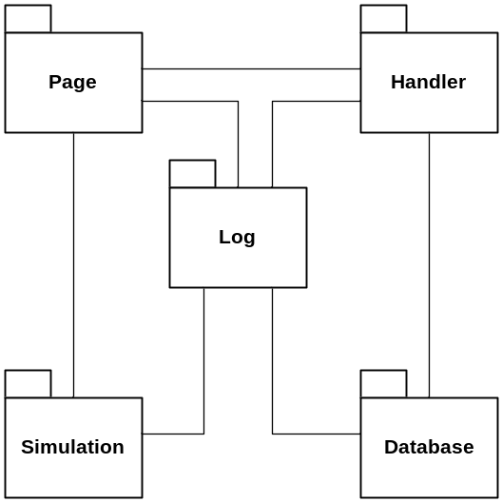

4.1.1 Page Subsystem
The Page subsystem is one of the main components of the XGene 360 application. It creates the user interface, processes user data, and manages the interaction between the XGene 360 application and each of the four user types: Administrator, Professor, TA, and Student.

The subsystem is primary responsible for generating the appropriate user interface for each of the user types base on the privilege level specified by the User object. The creation, deletion, and modification of users, courses, and problems along with the association and disassociation of problems with users and courses are managed within this subsystem. Furthermore, the subsystem takes database records and biological data to generate various HTML snippets to display the data in tables or graphs. Common functions, scripts, user interfaces, and variables that are shared among all types of users such as login, changing password, logout, header and footer pages are also managed by this subsystem.

4.1.2 Simulation Subsystem
The Simulation subsystem is the core component of the XGene 360 application. It is responsible for performing all biological simulation related operations such as calculating the trait values of plants, crossing selected parents, and producing the next generation by recombining genes.

4.1.3 Database Subsystem
The Database subsystem is the central access point to the database. Any operations that require the retrieval or modification of the data in the database will be done through the Database subsystem. The subsystem is primarily responsible for creating the connection to the DBMS; however, the subsystem itself does not contain any SQL statements. All SQL statements will be stored in the proxy class for each subsystem that will interact with the Database class.

4.1.4 Log Subsystem
The Log subsystem is responsible for tracking errors and SQL transactions throughout the execution of the XGene 360 application. These errors include SQL error, user login error, and other errors that is considered to be a circumstance in which the system malfunctions and does not perform the expected behaviour. Examples of transactions include the creation of a TA, or the modification of a problem. The Log subsystem can be called from all classes to report an error.

4.1.5 Handler Subsystem
The Handler subsystem is responsible for the creating and maintaining the information that is necessary for server to identify users, handling page redirection, and generating the SQL statements.

4.2 User View

User View of XGene 360 (Component Diagram):

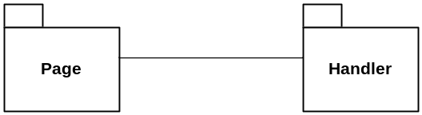

The access to XGene 360 application is authorized by login process. A successful login occurs when the username and the password, provided by the user, is equivalent to one of the entries in the database. If no corresponding entry is found, the user will be denied to access the application, and an error message will be displayed to the user. If the authentication is successful, the corresponding User object is created, which will be used to determine the privilege level of the user.

Each page of XGene 360 application will perform security check, to ensure the User object is allowed to execute the operation. If the user does not have the appropriate access level to carry out the operation, the operation will be cancelled, and a corresponding error message will be displayed. This security measure is required, to prevent users from accessing pages illegally, for which he/she is not entitled to. The application attempts to minimize unauthorized accesses to restricted information such as problem parameters or solutions.

5. Low Level Design

5.1 Modules

5.1.1 Page

The Page module is made up of the following files.

/changepassword.php
/index.php
/initialization.php
/login.php?Username=
/logout.php

/includes/config.inc
/includes/footer.inc
/includes/global.inc
/includes/header.inc
/includes/navi.inc

/admin/managecourses.php
/admin/manageproblems.php
/admin/manageprofessors.php
/admin/managestudents.php
/admin/managetas.php
/admin/viewcourse.php?courseid=
/admin/viewproblem.php?problemid=
/admin/viewprofessor.php?professorid=
/admin/viewstudent.php?studentid=
/admin/viewstudentsolution.php?studentid=&problemid=
/admin/viewta.php?taid=

/student/submitproblem.php?problemid=
/student/viewgeneration.php?problemid=&generationid=
/student/viewproblem.php?problemid=
/student/viewproblems.php
/student/viewsolution.php?problemid=

5.1.2 Simulation

The Gene class models the genes of plants as a String. The Trait class models the traits of plants with a trait name, the highest and lowest possible values for that particular trait, and the difference between the values. The Plant class models a plant with two traits. Each trait can be controlled by an arbitrary number of genes, in which the number lies between 2 and 50. The Simulator class provides the methods for biological simulation.

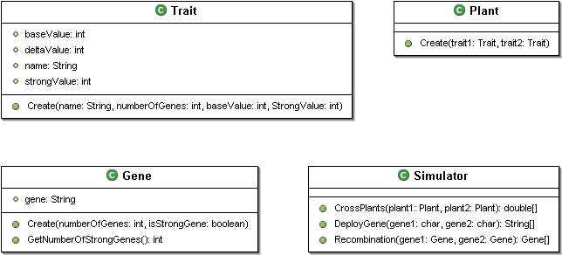

5.1.3 DatabaseManager

The DatabaseManager module performs all database related activity. Upon creation, it establishes a connection with the database. As we have not finalized what kind of queries to make to the database, the methods for this module are incomplete.

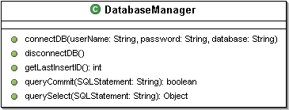

5.1.4 Logger

System errors and SQL transactions are handled by the Log module. This module is primarily responsible for recording system errors and successful transactions, meaning that it will not register invalid actions performed by users, or aborted transactions.

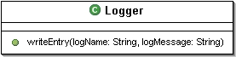

5.1.5 Handler

The UserHandler class authenticates the user, and returns a User object, created by the User class, upon success. The PageHandler class redirects the user to his/her starting page base on the privilege level specified by the User object, created after authentication. The CookieHandler class provides the server the ability to identify different users through cookies. This information is then used to validate the users on each page to ensure that the user has privilege to access the information. The SQLHandler class acts as a proxy to the Database subsystem by generating the SQL statements for the application. As we have not finalized what kind of queries to make to the database, the methods for this class are incomplete.

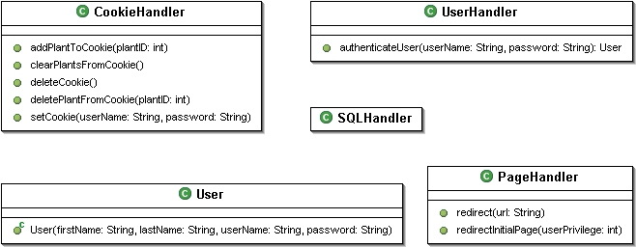

5.2 Sequence Diagrams
Please take note that there are a lot of functions that have very similar sequence diagrams. In order to increase readability of the document, any word surrounded by “[“ and “]” brackets will be denoted as variables. The tables below the sequence diagram will show a listing of the types of functions the particular sequence diagram is representing. The sections are grouped by sequence diagram, rather than by user, for similar reasons.

5.2.1 Common Login Sequence Diagram

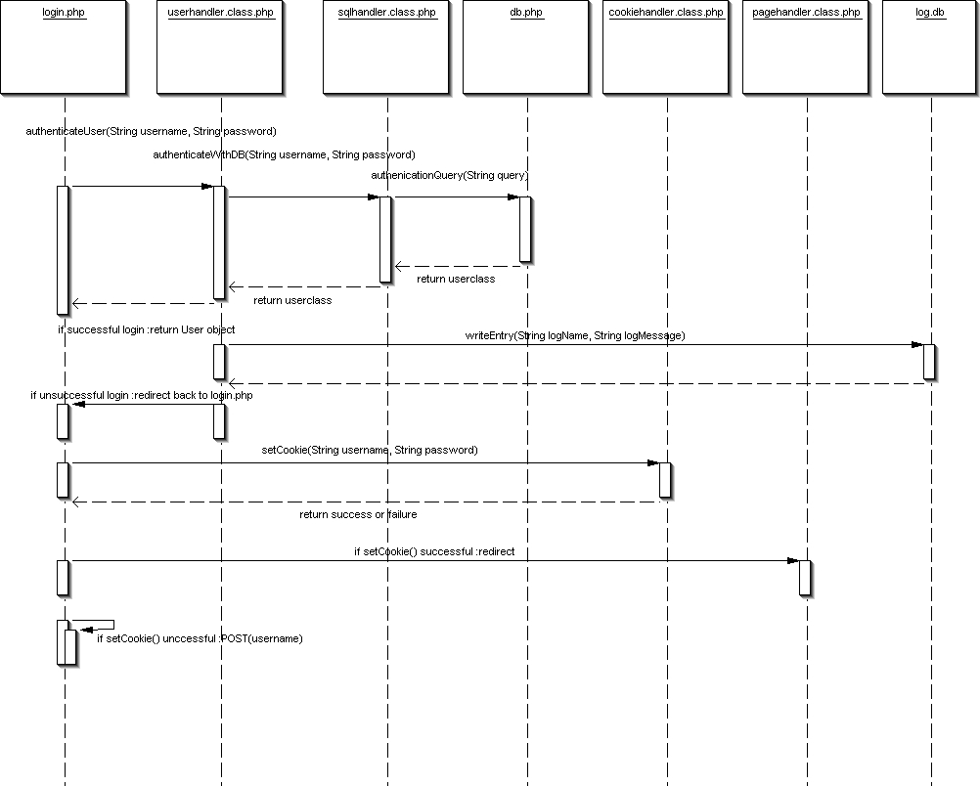

Common Sequence | Description
Login | Given a username and password as input, the system attempts to verify whether the user is in the database. If success, then the user is logged in. In the case of failure, the user is prompt to try again.

5.2.2 Common Logout Sequence Diagram

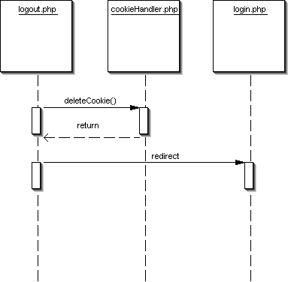

Common Sequence | Description
Logout | Given a prompt from the user to logout. The system will notify the cookie handler to delete the user’s cookie and then redirects the user to the login page.

5.2.5 Solve Problem Sequence Diagram

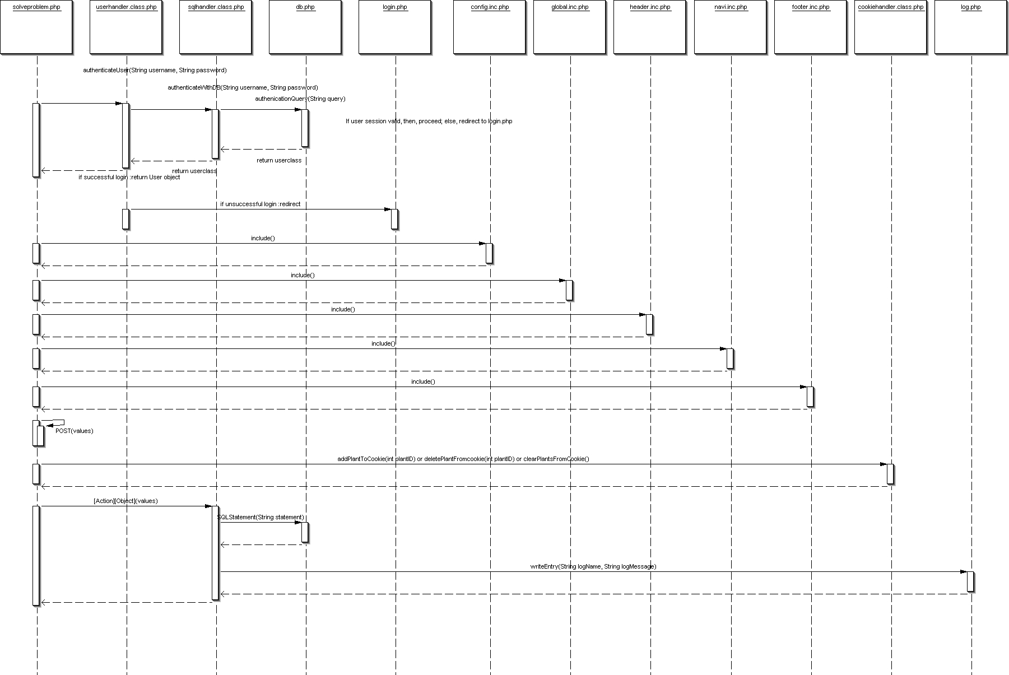

Sequence | Description
Solve Problem | Upon request for action, the system verifies the authentication of the username and password before allowing the student to be able to solve a problem.

5.2.6 [Action] [Object] Sequence Diagram

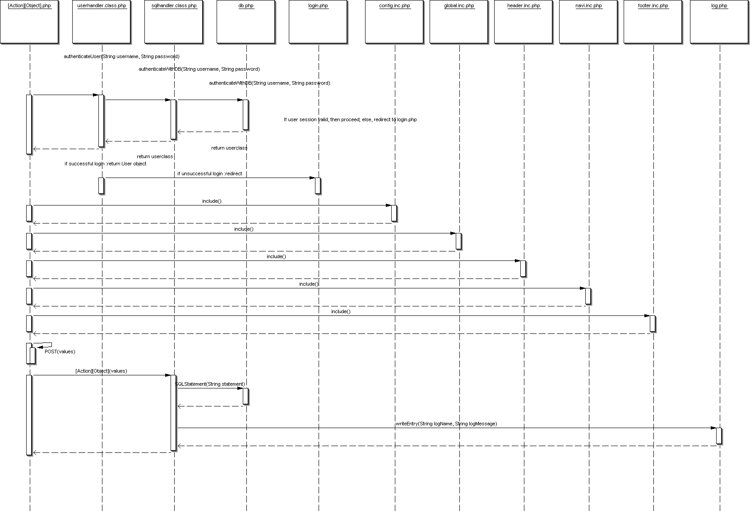

[Action] | [Object] | Description
Modify | Options | Upon selection, the system verifies the authentication of the username and password before allowing the user to view the modification pages.
Create/Delete/Modify | Administrator (once)  Professor  TA  Student  Problem  Courses  Feedback | Upon selection, the system verifies the authentication of the username and password before allowing the professor to see the page that allows him/her to create, delete or modify any one of the listed objects.
Associate/Disassociate | StudentsToCourse  TAsToCourse  StudentsToProblem  TAsToProblem | Upon selection, the system verifies the authentication of the username and password before allowing the professor to see the page that allows him/her to associate, disassociate any one of the listed objects.
View | Professor  TA  Student  Problem  Courses  Feedback  Generation  List of Generations | Upon selection, the system verifies the authentication of the username and password before allowing the user to view the page that displays the listed objects that the user is allowed to see.
Submit | Problem | Upon selection, the system verifies the authentication of the username and password before allowing the student see the page that will allow him/her to submit his/her solutions to be stored in the database.

6. User Interface Design

